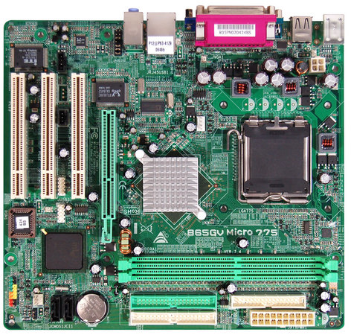 | 865GV Micro 775 7.x  - Socket LGA 775  - Supports Pentium D/Pentium 4/Celeron D Processor  - Supports FSB 400MHz/533MHz/800MHz  - Support Intel Hyper-Threading Technology  - Supports BIO-Remote 2 Technology

Chipset | - Intel 865GV&nbsp;/&nbsp;ICH5
CPU SUPPORT | - Intel® Pentium® D Processor  - Intel® Pentium® 4 Processor  - Intel® Celeron® D Processor
FSB | - Support FSB 533/800MHz
MEMORY | - Support Dual Channel DDR 200/266/333/400 MHz  - 2 x DDR DIMM Memory Slot  - Max. Supports up to 2GB Memory
INTEGRATED VIDEO | - Intel Extreme Graphics 2 , On Board Graphic Max. Share Memory Up To 64MB
STORAGE | - 2 x SATA Connectors  - 2 x IDE Connector
LAN | - Realtek RTL8100C - 10/100 Controller
CODEC | - Realtek ALC655 6-Channel AC97 Audio
USB | - 4 x USB 2.0 Port  - 2 x USB 2.0 Header
EXPANSION SLOT | - 3 x PCI Slot  - 1 x XGP Slot
REAR I/O | - 1 x PS/2 Mouse  - 1 x PS/2 Keyboard  - 4 x USB 2.0 Port  - 1 x COM Port  - 1 x Printer Port  - 1 x VGA Port  - 1 x LAN port  - 3 x Audio Jacks
INTERNAL I/O | - 2 x USB 2.0 Header  - 2 x SATA Connector  - 2 x IDE Connector  - 1 x Floppy Connector  - 1 x Front Audio Header  - 1 x Front Panel Header  - 1 x CD-IN Header  - 1 x S/PDIF-Out Header  - 1 x CPU Fan Connector  - 1 x System Fan Connector
DIMENSION | - Micro ATX Form Factor Dimension: 21.5cm X 23.5cm ( W x L )
OS SUPPORT | - Support Windows 2000 / XP
ACCESSORIES | - 1 x IDE Cable  - 1 x FDD Cable(Optional)  - 1 x SATA Cable(Optional)  - 1 x I/O Shield  - 1 x Fully Setup Driver CD  - 1 x User Manual

